

Database Design

Sany3y
Version 1.0

Nov of 2025

Table of Contents

Team Members 3
Introduction 3
Database Objectives 3
Entities and Attributes 4
Relationships 6
ERD 7
Summary 7

Team Members
ID | Name | Email
21030343 | Mohammed Atef | mohamed45452020@gmail.com
21060536 | Steven Amin | stevenameen02@gmail.com
21040560 | Omnia Ashraf | omniaamohamed102@gmail.com
21056226 | Kenzi Shibl | kebzishibl@gmail.com

Introduction
This document outlines the database design for the Sany3y full-stack website. It defines entities, relationships, constraints, and data structures required to support the platform's operations.

Database Objectives
- Ensure data consistency and integrity.
- Support user, technician, booking, and admin operations.
- Provide efficient querying for dashboard analytics.
- Enable scalable growth for future platform expansion.

Entities and Attributes
Entity | Description | Key Attributes
ProfilePicture | Stores the paths of users' profile pictures | - ProfilePicID (PK)  - ProfilePicPath
Addresses | Stores address details (street, city, governorate) | - AddressID (PK)  - Street  - City  - Governorate
Categories | Represents the categories of services or skills in the system | - CategoryID (PK)  - Name  - Description
Users | Stores information about system users (clients/technicians) | - UserID (PK)  - Email (Unique)  - Fname  - Lname  - Password  - PhoneNumber  - NationalID  - Gender  - Username  - CreatedAt  - ProfilePicID (FK)  - AddressID (FK)  - CategoryID (FK)
Tasks | Tasks created between clients and technicians | - TaskID (PK)  - Title  - Description  - Status  - CategoryID (FK)  - ClientID (FK)  - TaskerID (FK)
Notifications | Notifications sent to users | - NotificationID (PK)  - Message  - Type  - CreatedAt  - IsReaded  - UserID (FK)

Messages | Messages exchanged between clients and technicians | - MessageID (PK)  - Content  - SentAt  - SenderID (FK)  - ReceiverID (FK)
Ratings | Ratings given by clients to technicians after completing tasks | - RatingID (PK)  - Score  - Comment  - TaskID (FK)  - ClientID (FK)  - TaskerID (FK)
PaymentMethod | Available payment methods in the system | - PaymentMethodID (PK)  - Name  - Description  - IsActive
Payments | Records payments related to tasks | - PaymentID (PK)  - AmountAgreed  - AmountPaid  - PaymentDate  - PaymentStatus  - TaskID (FK)  - PaymentMethodID (FK)  - ClientID (FK)
Roles | User roles (Admin / Client / Technician) | - RoleID (PK)  - Name  - Description
User_Roles | Many-to-many relationship between users and roles | - RoleID + UserID (Composite PK)  - RoleID (FK)  - UserID (FK)
TechnicianSchedules | Schedules for technicians showing availability | - ID (PK)  - Date  - StartTime  - EndDate  - IsBooked  - TechnicianID (FK)

Relationships
Relationship | Type | Description
ProfilePicture → Users | One-to-Many | Each user has one profile picture, but a profile picture could theoretically be linked to multiple users (depending on your design, usually 1-to-1).
Addresses → Users | One-to-Many | Each user has one address, but an address can belong to multiple users.
Categories → Users | One-to-Many | Each user belongs to one category (e.g., skill), each category can have many users.
Categories → Tasks | One-to-Many | Each task belongs to a category; a category can have many tasks.
Users → Tasks (Client) | One-to-Many | Each client can create many tasks; each task has one client.
Users → Tasks (Tasker/Technician) | One-to-Many | Each technician can be assigned to many tasks; each task has one technician.
Users → Notifications | One-to-Many | Each user can receive many notifications.
Users → Messages (Sender) | One-to-Many | Each user can send many messages.
Users → Messages (Receiver) | One-to-Many | Each user can receive many messages.
Tasks → Ratings | One-to-Many | Each task can have ratings.
Users → Ratings (Client) | One-to-Many | Each client can rate multiple tasks.
Users → Ratings (Tasker) | One-to-Many | Each technician can be rated multiple times.
PaymentMethod → Payments | One-to-Many | Each payment method can be used for many payments.
Tasks → Payments | One-to-Many | Each task can have many payments.
Users → Payments (Client) | One-to-Many | Each client can make many payments.
Roles → User_Roles | One-to-Many | Each role can be assigned to many users.
Users → User_Roles | One-to-Many | Each user can have multiple roles.
Users → TechnicianSchedules | One-to-Many | Each technician can have multiple schedule entries.

ERD
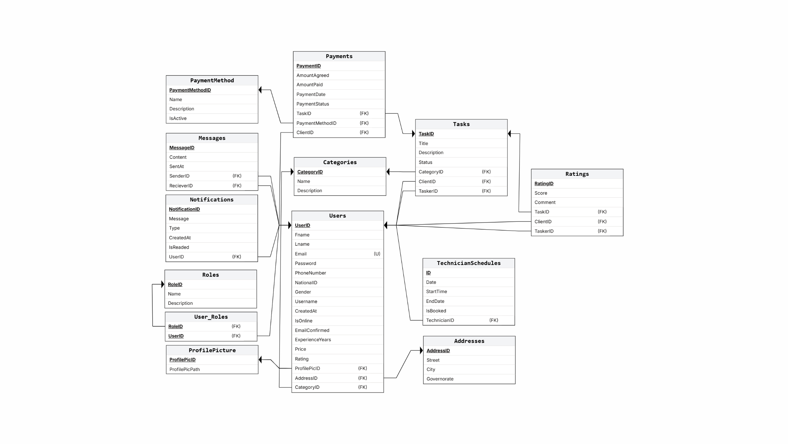

Summary
This database design supports the core functionalities of the Sany3y platform, ensures data integrity, allows scalability, and maintains efficient query performance.

